Experiment No: 7
Build an Artificial Neural Network (ANN) using Keras/TensorFlow

1. Dataset Source
Churn Modelling Dataset
Source Link:
https://www.kaggle.com/datasets/shrutimechlearn/churn-modelling

2. Dataset Description
The dataset contains information about bank customers and whether they leave the bank (churn) or not.
- Number of Instances: ~10,000
- Number of Features: 14

🔹 Features:
- CreditScore
- Geography
- Gender
- Age
- Tenure
- Balance
- NumOfProducts
- HasCrCard
- IsActiveMember
- EstimatedSalary

🔹 Target Variable:
- Exited
  - 0 = No Churn
  - 1 = Churn

3. Mathematical Formulation
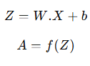
ANN consists of layers of neurons.

🔹 Neuron Formula:
Where:
- WWW = weights
- XXX = inputs
- bbb = bias
- fff = activation function (ReLU, Sigmoid)

4. Algorithm Limitations
- Requires large data
- Computationally expensive
- Hard to interpret
- Needs tuning

5. Methodology / Workflow
- Load dataset
- Data preprocessing
  - Handle missing values
  - Encode categorical data
  - Feature scaling
- Split dataset
- Build ANN model
- Train model
- Evaluate performance
- Tune parameters

6. Performance Analysis
Metrics:
- Accuracy
- Confusion Matrix
ANN performs well for complex patterns and improves prediction accuracy.

7. Hyperparameter Tuning
- Number of layers
- Number of neurons
- Activation function
- Epochs, batch size

Code:
# ================= STEP 1: IMPORT =================
import numpy as np
import pandas as pd
import matplotlib.pyplot as plt
import seaborn as sns

from sklearn.model_selection import train_test_split
from sklearn.preprocessing import StandardScaler
from sklearn.metrics import accuracy_score, confusion_matrix

import tensorflow as tf
from tensorflow import keras
from tensorflow.keras import layers

# ================= STEP 2: LOAD DATA =================
df = pd.read_csv("Churn_Modelling.csv")

print(df.head())

# ================= STEP 3: PREPROCESSING =================
# Drop unnecessary columns
df = df.drop(columns=['RowNumber', 'CustomerId', 'Surname'])

# Encode categorical
df = pd.get_dummies(df, columns=['Geography', 'Gender'], drop_first=True)

# Split features and target
X = df.drop(columns=['Exited'])
y = df['Exited']

# Scaling
scaler = StandardScaler()
X = scaler.fit_transform(X)

# Train test split
X_train, X_test, y_train, y_test = train_test_split(
X, y, test_size=0.2, random_state=42
)

# ================= STEP 4: BUILD ANN =================
model = keras.Sequential([
layers.Dense(16, activation='relu', input_shape=(X_train.shape[1],)),
layers.Dense(8, activation='relu'),
layers.Dense(1, activation='sigmoid')
])

# Compile
model.compile(
optimizer='adam',
loss='binary_crossentropy',
metrics=['accuracy']
)

# ================= STEP 5: TRAIN =================
history = model.fit(
X_train, y_train,
epochs=20,
batch_size=32,
validation_split=0.2
)

# ================= STEP 6: PREDICT =================
y_pred = model.predict(X_test)
y_pred = (y_pred > 0.5)

# ================= STEP 7: EVALUATION =================
print("Accuracy:", accuracy_score(y_test, y_pred))

cm = confusion_matrix(y_test, y_pred)

# Confusion Matrix Image
plt.figure(figsize=(5,4))
sns.heatmap(cm, annot=True, fmt="d", cmap="Purples")
plt.xlabel("Predicted")
plt.ylabel("Actual")
plt.title("Confusion Matrix - ANN")
plt.show()

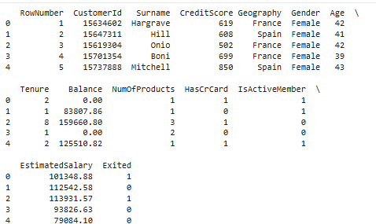

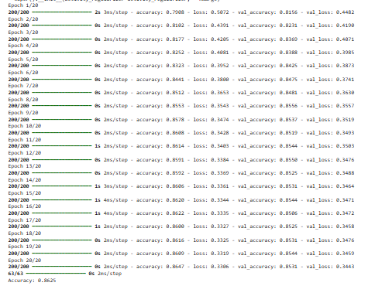
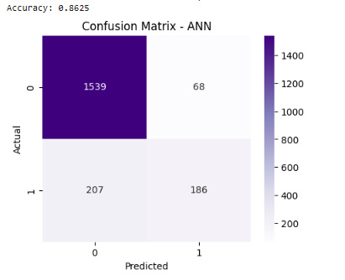

Conclusion:
An Artificial Neural Network was successfully built using TensorFlow/Keras. The model effectively learned patterns in the dataset and provided good classification accuracy.

